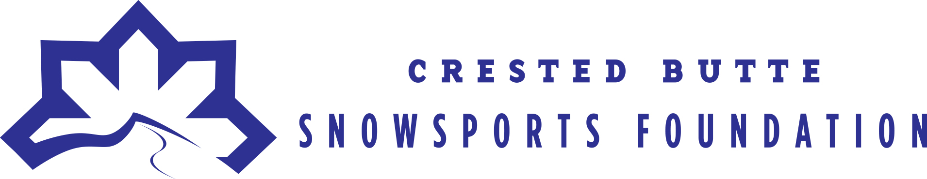
Partner Program Grant Guidelines
2016-2017

Mission Statement
The Crested Butte Snowsports Foundation provides financial support for the youth in Crested Butte and Gunnison in their pursuit of sportsmanship, passion, excellence and discipline through snow sport experiences.
Our goals are to:
- Provide merit and need based scholarships for local youth.
- Educate through snow sports.
- Increase participation in partner programs each year.
- Create networks to attract and organize quality snow sport events.
General Grant Guidelines
The Crested Butte Snowsports Foundation awards grants to (in this priority):
- Competitive and developmental snow sport programs.
- Snow sport events.

Partner Programs and Events
In order to ensure that all funds distributed by the Crested Butte Snowsports Foundation (CBSF) make a direct impact on the Foundation’s mission and goals, the Foundation only awards grants to approved programs. Programs requesting funding are required to submit an application to CBSF by November 1, 2016, confirming that it meets the Foundation’s guidelines.
This application will also serve as the evaluative criteria for partner programs and events, and the Foundation will review each program’s performance on an annual basis.
We cannot guarantee funding for every grant request received. If you are awarded a grant, funding may not be available until 2017.
Should you have any questions, please reach out to Kate King, Executive Director at kate@cbsnowsports.org or 970.349.2830. Thank you for taking the time to apply for a Crested Butte Snowsports Foundation grant.

